User Manual

NSW Traffic Penalty Tool

# Purpose

This user manual provides instructions on how utilise the NSW Traffic Penalty Data Tool (NTPT). The purpose of the NTPT is to allow the user to view data relating to traffic penalties in NSW, from early 2011 to late 2016. Within the ‘Main Page’, users can choose a start date and end date, choose whether the offence occurred in a school zone, search for specific cases as well as refresh the data tool. For the ‘Distribution of Cases Page’, the user will be presented with a pie chart that represents the percentage of cases according to offence code. For the ‘Captured by Radar or Camera Page’, the user will be presented with a line chart, which compares the number of offences caught on radar and number of offences caught by camera. For the ‘Mobile Phone Usage Page’, the user will be presented with a bar chart, displaying the number of cases caused by mobile phone usage. For the ‘School Zone Page’, the user will be presented with a bar chart, representing cases that occurred within a school zone. Each pages’ visualisation can be changed according to user preferences.

# Target Audience

It is expected that the user has access to a computer, basic experience using software programs and can read the English language. The target audience for the NTPT are the employees of the government agency Transport for NSW (TfNSW). However, the data tool caters to any individual that would like to view significant penalty trends in NSW, whether for personal or professional purposes.

# Instructions

## Main Page

Users first see the Main Menu, with the first button allowing the user to view the ‘Main Page’.

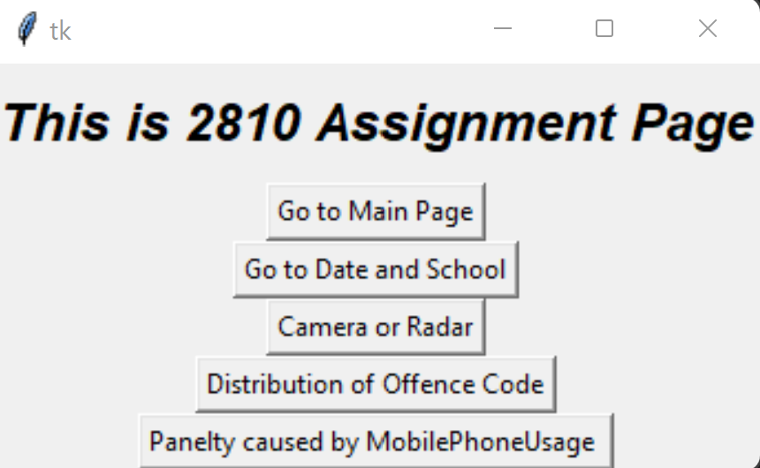

Figure - Main Menu

The ‘Main Page’ allows the user to view the automatically generated set of cases. However, if users click the ‘Go to Date and School’ button, users may see each individual case. Each case will have an offence year, offence month, offence code, offence description, associated legislation, associated clause (from legislation), face value and whether it was identified on camera.

To view cases in a specific time frame, the user can change the start year, start month, end month and end year. To change the start year, click on the ‘Start Year’ dropdown box. The user can select years from 2011 to 2016. The user must click on the preferred year. These steps can be used to change the end year; users must click the ‘End Year’ dropdown box instead. To change the start month, click on the ‘Start Month’ dropdown box. The user can select months from 1 (January) to 12 (December). The user must click on the preferred month. These steps can be used to change the end month; users must click the ‘End Month’ dropdown box instead. Once preferences are set, the user must click the ‘Search’ button. This will display data within the users’ chosen dates.

To view cases that occurred in a school zone, the user must tick the ‘School Zone’ checkbox. To view cases that occurred outside a school zone, click the ‘School Zone’ checkbox until a tick is no longer visible.

## Distribution of Cases Page

Users can view the ‘Distribution of Cases Page’ by clicking on the ‘Distribution of Offence Code’ button in Figure 1 . Each offence code will be presented as a ‘piece of the pie’ and have a percentage associated with said offence code.

To view offence percentages in a specific time frame, the user can change the start year, start month, end month and end year. To change the start year, click on the ‘Start Year’ dropdown box. The user can select years from 2011 to 2016. The user must click on the preferred year. These steps can be used to change the end year; users must click the ‘End Year’ dropdown box instead. To change the start month, click on the ‘Start Month’ dropdown box. The user can select months from January to December. The user must click on the preferred month. These steps can be used to change the end month; users must click the ‘End Month’ dropdown box instead. Once preferences are set, the user must click the ‘Search’ button. This will display data within the users’ chosen dates.

For example, the user selects 2012 as the start year, selects 1 as the start month, end year as 2014 and end month as 1. This means that the pie chart will only display offence code percentages with cases that occurred from the 1st of January 2012 to the 1st of January 2014.

To view offences that occurred in a school zone, the user must tick the ‘School Zone’ checkbox. To view cases that occurred outside a school zone, click the ‘School Zone’ checkbox until a tick is no longer visible.

Each time the user changes preferences and clicks the ‘Search’ button, a pop up of the graph will appear.

## Captured by Radar or Camera Page

Users can view the ‘Captured by Radar or Camera Page’ by clicking the ‘Camera or Radar’ button on Figure 1. Each case caught on camera will be displayed, along with each cause captured by radar. Camera cases will be shown on their own line and so will radar cases.

To view captured cases in a specific time frame, the user can change the start year, start month, end month and end year. To change the start year, click on the ‘Start Year’ dropdown box. The user can select years from 2011 to 2016. The user must click on the preferred year. These steps can be used to change the end year; users must click the ‘End Year’ dropdown box instead. To change the start month, click on the ‘Start Month’ dropdown box. The user can select months from 1 (January) to 12 (December). The user must click on the preferred month. These steps can be used to change the end month; users must click the ‘End Month’ dropdown box instead. Once preferences are set, the user must click the ‘Search’ button. This will display data within the users’ chosen dates.

To view captured cases that occurred in a school zone, the user must tick the ‘School Zone’ checkbox. To view cases that occurred outside a school zone, click the ‘School Zone’ checkbox until a tick is no longer visible.

Each time the user changes preferences and clicks the ‘Search’ button, a pop up of the graph will appear.

## Mobile Phone Usage Page

Users can access the ‘Mobile Phone Usage Page’ by clicking the ‘Penalty Caused By Mobile Phone Usage’ in Figure 1. Each case caused by mobile phone usage will be displayed.

To view mobile phone cases in a specific time frame, the user can change the start year, start month, end month and end year. To change the start year, click on the ‘Start Year’ dropdown box. The user can select years from 2011 to 2016. The user must click on the preferred year. These steps can be used to change the end year; users must click the ‘End Year’ dropdown box instead. To change the start month, click on the ‘Start Month’ dropdown box. The user can select months from 1 (January) to 12 (December). The user must click on the preferred month. These steps can be used to change the end moth; users must click the ‘End Month’ dropdown box instead. Once preferences are set, the user must click the ‘Search’ button. This will display data within the users’ chosen dates.

To view mobile phone cases that occurred in a school zone, the user must tick the ‘School Zone’ checkbox. To view cases that occurred outside a school zone, click the ‘School Zone’ checkbox until a tick is no longer visible.

Each time the user changes preferences and clicks the ‘Search’ button, a pop up of the graph will appear.

## School Zone Page

The ‘School Zone Page’ can be accessed by users by clicking on any button presented in Figure 1, as long as the ‘School Zone’ checkbox has been ticked.

To view school zone cases in a specific time frame, the user can change the start year, start month, end month and end year. To change the start year, click on the ‘Start Year’ dropdown box. The user can select years from 2011 to 2016. The user must click on the preferred year. These steps can be used to change the end year; users must click the ‘End Year’ dropdown box instead. To change the start month, click on the ‘Start Month’ dropdown box. The user can select months from 1 (January) to 12 (December). The user must click on the preferred month. These steps can be used to change the end month; users must click the ‘End Month’ dropdown box instead. Once preferences are set, the user must click the ‘Search’ button. This will display data within the users’ chosen dates.

Each time the user changes preferences and clicks the ‘Search’ button, a pop up of the graph will appear.

# Dictionary

Table - Data Set Type and Description